The Style Invitational Week 809 Unkindest Cutlines
Saturday, March 21, 2009; C02

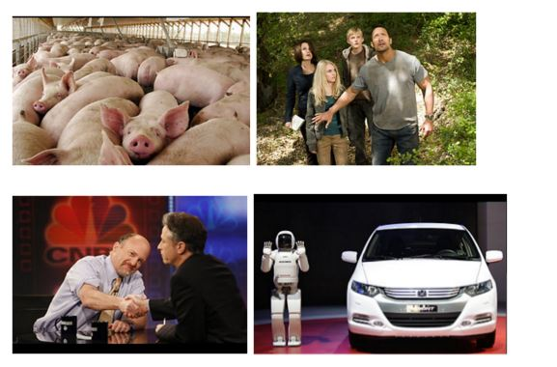Before print newspapers are subsumed entirely into the online ether, a bit of soon-to-be-ancient terminology: What the rest of the world calls a photo caption, the newspaper world calls a "cutline," a word dating back to when images were "cut," or engraved, into the printing plate. "Caption" (deriving from the Latin word for "head") referred to a headline above the picture, but that usage has pretty much vanished. "Cutline," however, remains. This week: For once, a simple premise: Supply cutlines, or captions, for any one of the newspaper photos in the slideshow.

Winner gets the Inker, the official Style Invitational trophy. Second place receives a plastic box, a little smaller than your standard tissue box, in the shape (pretty much) of the White House. When you lift the lid, it begins to play "The Star-Spangled Banner" at great volume. Gotten rid of by Big-Deal Loser Beverley Sharp of Washington as she prepares to get rid of Washington and move back South.

Other runners-up win a coveted Style Invitational Loser T-shirt. Honorable Mentions get one of the lusted-after Style Invitational Magnets. First Offenders get a smelly tree-shaped air "freshener" (Fir Stink for their First Ink). One prize per entrant per week. Send your entries by e-mail to losers@washpost.com or by fax to 202-334-4312. Deadline is Monday, March 30. Put "Week 809" in the subject line of your e-mail, or it risks being ignored as spam. Include your name, postal address and phone number with your entry. Contests are judged on the basis of humor and originality. All entries become the property of The Washington Post. Entries may be edited for taste or content. Results will be published April 18. No purchase required for entry. Employees of The Washington Post, and their immediate relatives, are not eligible for prizes. Pseudonymous entries will be disqualified. This week's Honorable Mentions name is by Kevin Dopart; the revised title for next week's results is by Dave Prevar.

Report From Week 805, in which we asked for bad names for any of five particular items. As when we did this contest a decade ago, the results aren't exactly cerebral. But we can't be pointy-headed every week -- it plays havoc with the Empress's crown. Among the thousands of entries were the far too frequent Sam 'n' Ella's Burgers/Peanut House, the Floaty and Mars Uranus candy bars and the Madoff School of Ethics.

4. A bad name for a Web site: www.si-m_p-l_i-f_y-y_o-u_r-l_i-fe.com (Alan Hochbaum, Atlanta)

3. A bad name for a beauty product: Great Personality (Jay Shuck, Minneapolis; Roy Ashley, Washington)

2. the winner of the toilet paper with pictures of Jimmy Carter: A bad name for a fast-food restaurant: La Cucaracha Taco House (Dean Evangelista, Rockville)

And the Winner of the Inker

A bad name for a candy bar: Herpes Kisses (Cy Gardner, Arlington)

The Worse for Wares: Honorable Mentions

A Bad Name for a New Beauty Product

Skin So Eh (J. Calvin Smith, Greenbelt)

Parfum de Barfum (Mae Scanlan, Washington)

Toxema (Kevin Mellema, Falls Church)

Back & Shoulders Dandruff Shampoo (Joe Harsel, Cockeysville, Md., who last got ink in 2002; Andrew Hoenig, Rockville)

Englishman's Pride Fluoride-Free Dentrifice (Chad Pridgen, Marshall, Va.)

You Look Just Like Your Mom! Lipstick (Melissa Yorks, Gaithersburg)

BlagoGel for Men (Anne Shively, Broadlands, a First Offender)

Oil of O'Lady (Dean Evangelista; Christopher Lamora, Arlington; Larry Yungk, Arlington)

Oil of NoLay (David Garratt, Glenn Dale)

Mean Nun Hair Clasp (Lee Dobbins, Arlington)

A Bad Name for a New Web Site

PixOfTheProphet.com (Stephen Dudzik, Olney)

20thCenturyTechSolutions.com (Tom Witte, Montgomery Village)

Fundownloads.com/activatevirus19534 (Andrea Birch, Wilmington, Del., a First Offender)

WitnessRelocationChatRoom.com (Joe Harsel)

WebstersDowloadableSpellchecker.com (Ellen Raphaeli, Falls Church)

Senatorcraigslist.com (Marlene C. Cohen, Silver Spring, a First Offender)

McCain2020.org (Peter Ostrander, Rockville)

A Bad Name for a New Candy Bar

High-Fructose Corn Syrup & Glycerine Treats (Jeff Brechlin, Eagan, Minn.)

Doo Doo Clusters (Tom Witte)

K-Y Jellybeans (Chris Doyle, on vacation in Livingstone, Zambia)

Liver Duds (Barry Koch, Catlett, Va.)

Scarburst (Tom Witte)

Peter Paul's Reduced-Fat Almond Mild Exuberance (Russell Beland, Fairfax)

A Bad Name for a New College

State Pen University (May Jampathom, Oakhurst, N.J.)

Gouger College (Larry Yungk)

Kwik-E-Smart (May Jampathon)

Ludd Institute of Technology (Tom Witte; Jeff Brechlin)

The University of Lake Ontario and Bait Shop (Martin Bancroft, Rochester, N.Y.)

Southern Utah Girls and Man College (Peter Jenkins, Bethesda)

The Caroline Kennedy School of Communications (David Kleinbard, Jersey City)

The Eastern Institute of Taxidermy and Culinary Arts (Ellen Raphaeli)

A Bad Name for a New Fast-Food Restaurant

Fetus Ruth (Kevin Dopart, Washington)

Head in the Box (Jon Reiser, Hilton, N.Y.)

Purger King (Kevin Dopart)

Pizza Bolus (Tom Murphy, Bowie)

The Ground Hound (Martin Bancroft)

Squirrel-fil-A (Steve Halter, Herndon, who last got ink in 1997)

Immodio's Pizza (Phil Frankenfeld, Washington)

S.H.I. Thursday's (Marty McCullen, Gettysburg, Pa.)

The Sweeney Toddle House (Pam Sweeney, St. Paul, Minn.; Chad Pridgen)

Long John Slivers (Mike Ostapiej, Tracy, Calif.)

Kentucky Fried Whatever (John O'Byrne, Dublin)

Pizza Hovel (Steve Johnson, Alexandria, a First Offender; Art Grinath, Takoma Park)

The Greasy Spleen (Roy Ashley)

Next Week: DQ Very Much, or Invali-Dating

